

Aptech Cinemas

Documentation

Authors | Group 4
Authors | Student1417931 - TRAN ANH TUAN  Student1415998 - MINH TO NHAT  Student1406279 - DO HOANG AN  Student1427066 - MAI VIET LONG  Student1406270 - LE VU TRINH TUNG  Student1415444 – DINH THE PHONG
Date | Start date is: May 29, 2025  End date is: July 7, 2025
Instructor | Nguyen Duc Hoang

Hanoi, tháng 06 năm 2025

Table of contents

Table of contents 2
Sincere thanks……………………………………………………………………………………………………………………………2
1. Problem Definition 3
1.1 Problem Abstraction 3
1.2 The Current System 3
1.3 The Proposed System 3
2. Customer Requirements Specification 6
2.1 Users of the System 6
2.2 System Functions 7
3. System Designs 7
3.1 Entity Relationship Diagram 7
3.2 Database Design 7
3.3 Data Flow Diagram 8
3.4 Sitemap 8
3.5 System Functions Design 12
4. Task sheet 27

Sincere thanks

To complete our fourth capstone project (e-Project 4), we have received tremendous support, encouragement, and assistance from many individuals and organizations. We – the members of the project team – would like to express our deepest gratitude to everyone who accompanied us throughout the development of this project.
First and foremost, we would like to extend our sincere thanks to Mr. NGUYỄN ĐỨC HOÀNG, our instructor, who has continuously supported us, provided thoughtful feedback, and offered invaluable advice that greatly contributed to the successful completion of e-Project 4. His encouragement and constructive responses played a crucial role in enhancing the quality and completeness of our product.
Next, we would like to thank the Aprotrain - Aptech Information Technology Training Center, along with all the lecturers and staff members, for their ongoing support and for creating a favorable learning environment throughout our studies and project implementation.
We also wish to express our heartfelt appreciation to our families – including parents, siblings, and loved ones – for their unconditional love, care, and support, especially during the intensive period of our project development.
Last but not least, we would like to acknowledge and thank all our classmates at Aptech. Your support, collaboration, and team spirit were a great source of motivation that helped us overcome challenges and strive toward greater goals in the future.
We sincerely thank you all!

1. Problem Definition

1.1 Problem Abstraction
In the context of growing demand for entertainment, going to the cinema has become a popular and familiar activity for many people. However, the traditional process of buying tickets at the counter faces many limitations such as long queues, lack of clear information about screening times, available seats, or suboptimal seat selection. This creates inconvenience for customers, especially during weekends or holidays when visitor numbers surge.
The core of the problem lies in the absence of a convenient and transparent online booking system that enables customers to easily search for showtimes, select movies, choose seats, and make payments anytime, anywhere. In addition, cinema operators also need a tool to manage schedules, screenings, seat availability, and ticket sales in an automated and systematic way, reducing workload for ticketing staff.
In summary, the problem to be solved is to develop a software solution that digitizes the movie ticket booking process, saving time, enhancing the customer experience, and optimizing the management and revenue operations for cinema businesses.

1.2 The Current System
Currently, most cinemas still rely on direct ticket sales at the counter or over the phone. Customers have to visit the cinema in person to buy tickets, choose screening times and seats, or make reservations by phone but still collect physical tickets at the counter before the show.
This process is inconvenient in many ways: long queues during peak hours, no real-time updates on seat availability, and difficulty in managing the number of guests per screening. Payment is often limited to cash, reducing flexibility for customers.
On the cinema side, managing show schedules, ticket sales, and seat assignments is often done semi-manually or using simple tools (e.g., spreadsheets), which can lead to errors, make it difficult to track ticket inventory, and result in inaccurate revenue reporting.
Overall, the current system fails to meet the need for automation and optimized customer experience in the digital age, while also increasing workload for staff and cinema management.

1.3 The Proposed System
The proposed online movie ticket booking application aims to replace the manual ticket purchasing process, delivering a convenient and modern experience for customers. The system is designed with clear boundaries, objectives, and functional scope as follows:
1.3.1 Boundaries of the System
- The system serves only for booking tickets for in-person cinema screenings; it does not support online streaming.
- Allows customers to browse movies, view showtimes (date and time), select seats, book tickets, and pay via PayPal.
- Manages movie and showtime information at a basic level (no separate theater/room management).
- Excludes staff management, physical theater facilities management, or inventory control.
1.3.2 System Objectives
- Automate the movie ticket booking process, reducing waiting time and manual errors.
- Provide an easy-to-use and transparent ticket booking experience for customers.
- Help cinema operators manage movie information, showtimes, seating, and bookings effectively.
- Ensure secure payment through PayPal.
1.3.3 System Scope
- Allow user registration, login, and personal account management.
- Enable customers to browse movies and view showtimes by date and time.
- Display available seating charts and support seat selection.
- Handle ticket booking and online payment via PayPal.
- Enable administrators to add, edit, and delete movie and showtime information.
- Manage seating layout and booking status.
- Store booking information and support revenue reporting.

1.3.4 Hardware and Software Requirements

Hardware Requirements:
- User devices: smartphones or tablets running Android (version 5.0 or higher) or iOS (version 11 or higher), recommended RAM ≥ 2 GB for smooth performance.
- Backend server: minimum configuration of 1 vCPU, 1 GB RAM, and sufficient storage for MySQL database and temporary data.

Software Requirements:
- Mobile app developed using Flutter 3.19.5 and Dart 3.3.3, applying the MVVM pattern to separate UI and business logic.
- Backend server implementing MVC architecture, providing REST APIs for the mobile app.
- MySQL database to store movie information, user accounts, bookings, and showtimes.
- Cloudinary service for storing and managing movie posters and cover images.
- Main Flutter libraries:
  - pie_chart, fl_chart for rendering charts of revenue and ticket sales statistics.
  - youtube_player_flutter for embedding and playing YouTube movie trailers.
  - intl for localization and formatting of language, dates, and times.

Development Operating System:
- Windows, macOS, or Linux for programming and building the Flutter app.
- MySQL Server on Linux or Windows.

The system is designed for easy deployment on cloud infrastructure or physical servers with suitable minimum configurations.

2. Customer Requirements Specification

2.1 Users of the System
The system is designed to serve various user groups, each with specific goals and interactions. The main user groups include:
1. Users
Purpose:
- Access information about planets, comets, and constellations.
- View engaging astronomical images.
- Read scientific articles and astronomy-related news.
- Submit questions or feedback via the contact form.
Characteristics:
- No login or account creation required.
- Interacts directly via web browsers.
- Can use desktop computers, tablets, or mobile devices.
2. Administrators
Purpose:
- Update, edit, or delete content related to astronomical objects, articles, images, and news.
- Manage user-submitted messages from the contact form.
- Monitor user access statistics to assess system performance.
Characteristics:
- Must log in to access the admin panel.
- Has special privileges to modify database content.
- Responsible for maintaining the accuracy, freshness, and security of the information.

2.2 System Functions
The online movie ticket booking system will provide the following main functions:
- Movie Management: add, edit, delete movie details (title, description, poster, trailer).
- Showtime Management: create and update showtimes with date, time.
- Showtime Display: allow customers to view the list of movies and schedules.
- Seat Selection: display seating chart, allow users to select available seats.
- Booking: handle the ticket booking process and save booking details.
- Online Payment: integrate payment gateway for ticket payment.
- User Management: user registration, login, and profile management.
- Admin Features: manage movies, showtimes, view sales reports, and booking records.

3. System Designs

3.1 Entity Relationship Diagram
The database relationships are primarily One-to-Many, enforced through Foreign Keys. This design enables robust management of ticket booking flows, movie details, showtimes, and seating. Below is a detailed description of the key relationships:
- cinemas – halls
  - One cinema has many halls.
  - Each hall belongs to exactly one cinema.
  - PK: cinemas.cinema_id ↔ FK: halls.cinema_id
- halls – seats
  - One hall contains many seats.
  - Each seat belongs to exactly one hall.
  - PK: halls.hall_id ↔ FK: seats.hall_id
- movies – showtimes
  - One movie can have multiple showtimes.
  - Each showtime is for exactly one movie.
  - PK: movies.movie_id ↔ FK: showtimes.movie_id
- halls – showtimes
  - One hall can have multiple showtimes.
  - Each showtime takes place in exactly one hall.
  - PK: halls.hall_id ↔ FK: showtimes.hall_id
  - Note: the showtimes table links movies and halls to define a specific screening schedule.
- users – bookings
  - One user can have many bookings.
  - Each booking belongs to one user.
  - PK: users.user_id ↔ FK: bookings.user_id
- showtimes – bookings
  - One showtime can have many bookings.
  - Each booking is for one showtime.
  - PK: showtimes.showtime_id ↔ FK: bookings.showtime_id
- bookings – booking_seats
  - One booking can include many booked seats.
  - Each booking_seat belongs to one booking.
  - PK: bookings.booking_id ↔ FK: booking_seats.booking_id
- seats – booking_seats
  - One seat can appear in many booking_seats records (for different bookings over time).
  - Each booking_seat references one seat.
  - PK: seats.seat_id ↔ FK: booking_seats.seat_id
- bookings – transactions
  - One booking can have multiple related transactions (e.g., payment and refunds).
  - Each transaction belongs to one booking.
  - PK: bookings.booking_id ↔ FK: transactions.booking_id
- bookings – tickets
  - One booking can generate multiple tickets.
  - Each ticket belongs to one booking.
  - PK: bookings.booking_id ↔ FK: tickets.booking_id
- seats – tickets
  - One seat can be issued as tickets for different bookings.
  - Each ticket references one seat.
  - PK: seats.seat_id ↔ FK: tickets.seat_id
Main booking flow diagram:
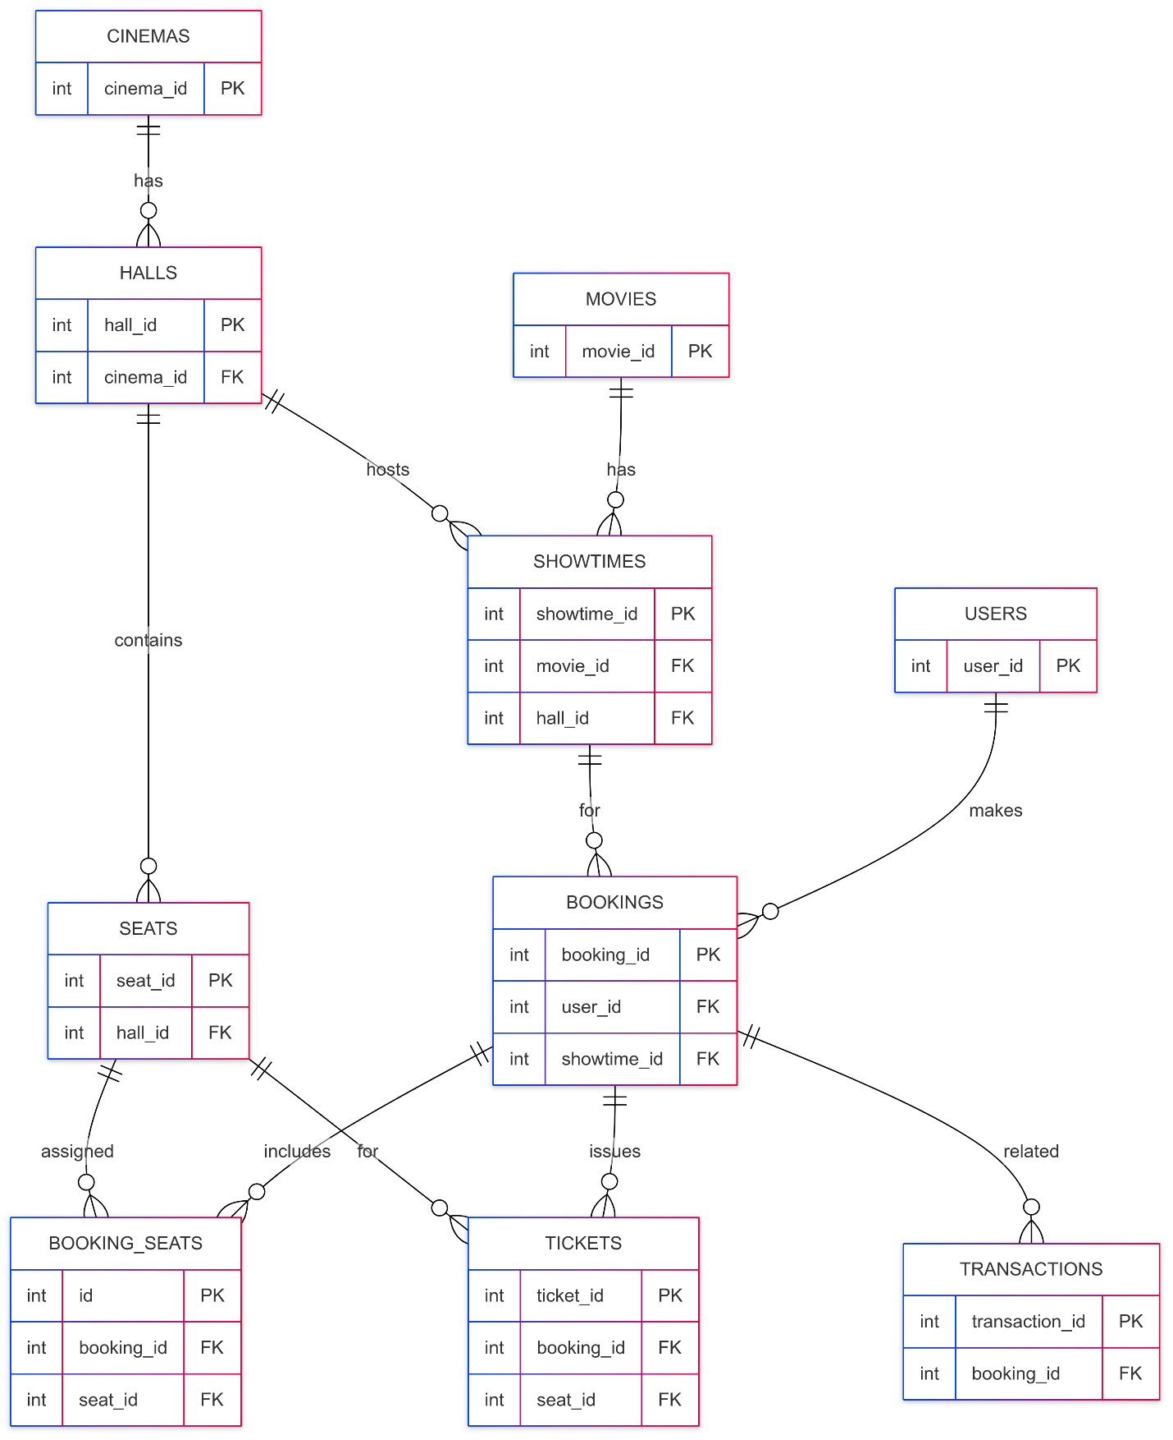

Note:
- The food_items and banners tables are independent, static data tables without direct foreign key relationships to the main booking flow. However, food_items are stored as JSON in the bookings table.
- The seat_type_prices table is a reference table used for triggers and price calculation logic.

3.2 Database Design

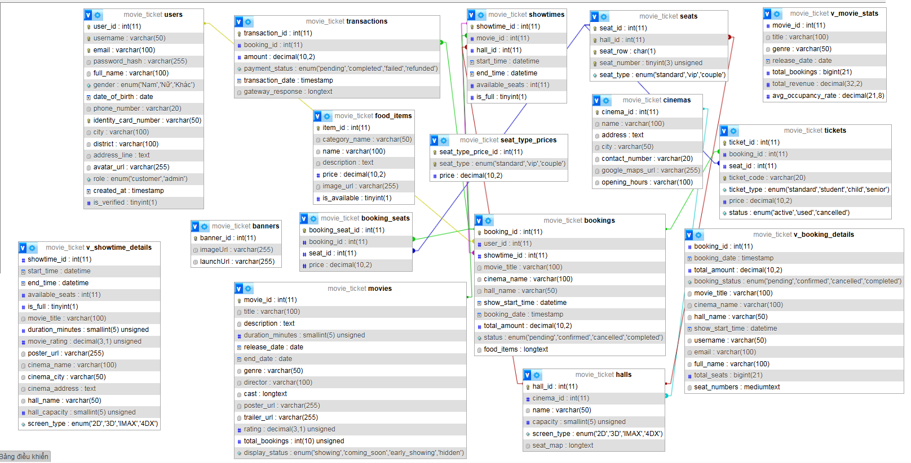

3.3 Data Flow Diagram
a. DFD Level 0 (Context Diagram)
The context diagram shows the system as a single process interacting with external entities (User, Admin, Payment Gateway, Cloudinary).
- Entities:
• User (Mobile App / Flutter)
• Admin (Admin Panel / React)
• Payment Gateway (PayPal)
• Image Storage (Cloudinary)
- Process:
• Movie Ticket Booking System
- Data Stores:
• MySQL Database
- Data Flows:
• User Requests (Register, Login, Browse Movies, Book Tickets, Pay)
• Admin Requests (Manage Movies, Showtimes, Cinemas, Seats, Food Items, Banners)
• Payment Processing (PayPal)
• Image Upload/Download (Cloudinary)
• Data Storage/Retrieval (MySQL)
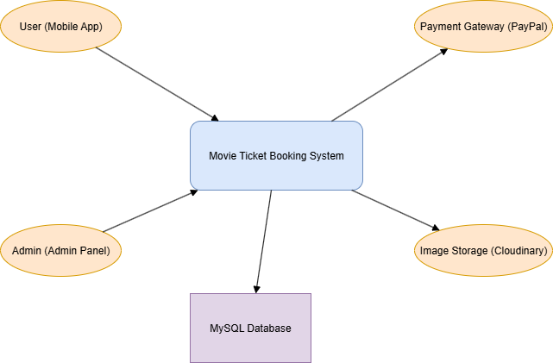

b. DFD Level 1 (Main Processes)
Breaks down the system into key processes for both User and Admin flows.
- Processes:
• 1.1 Register/Login (AuthController)
• 1.2 Search & Browse Movies (MoviesController)
• 1.3 Make Booking (BookingController)
• 1.4 Payment Processing (PayPal Integration)
• 1.5 Admin Management (CRUD Controllers for Movies, Showtimes, Seats, Food Items, Banners, Cinemas)
- Data Store:
• MySQL Database (tables: users, movies, showtimes, bookings, transactions, seats, food_items, banners)
- Data Flows:
• Credentials, JWT Tokens
• API Requests/Responses (RESTful)
• Booking Details
• Payment Requests & Confirmations
• Image Upload/Fetch via Cloudinary
• Admin CRUD Operations

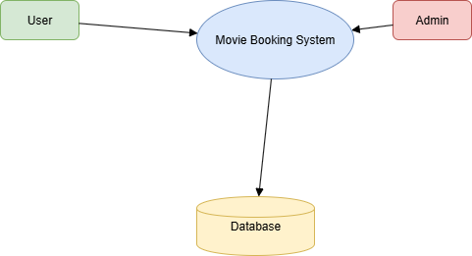

c. DFD Level 2 (Booking Process Breakdown)
Focuses on the "Make Booking" process (1.3), detailing steps from seat selection to payment.
- Processes:
• 2.1 Select Showtime & Seats (SeatSelectionScreen)
• 2.2 Create Pending Booking (BookingController.createBooking)
• 2.3 Pay with PayPal (BookingController.createPaypalPayment, executePaypalPayment)
• 2.4 Issue Tickets (BookingController)
• 2.5 View Transaction History (TransactionHistoryScreen)
- Data Store:
• MySQL Database
• Tables: showtimes, seats, bookings, booking_seats, transactions, tickets
- Data Flows:
• Select Showtime, Seats, Combos
• Create Pending Booking (Insert booking, booking_seats)
• Call PayPal API for Approval URL
• Handle PayPal Redirect/Execute Payment
• Update Booking Status (confirmed/cancelled)
• Insert Transactions & Tickets
• Fetch User Bookings & Transaction History

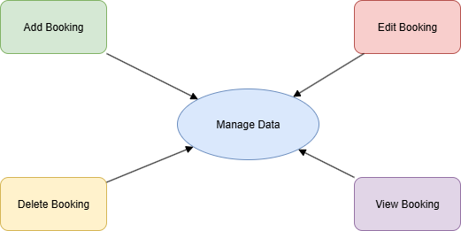

d. Admin Flowchart (Summary)
Description:
- Admin logs in via Admin Panel (React App).
- Dashboard allows navigation to management sections.
- Actions include:
• Add/Edit/Delete Movies
• Manage Showtimes
• Manage Cinemas, Halls, Seats
• Manage Food Items and Banners
- For each action:
• Form input is validated.
• Images are uploaded to Cloudinary if needed.
• Data is stored/updated in the MySQL Database via API Server.
• Success/error feedback is displayed.

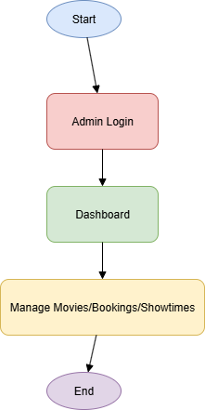

e. User Flowchart (Booking Process)
Description:
- User opens the Mobile App (Flutter).
- Logs in or registers an account.
- Browses movies and selects a showtime.
- Chooses seats and optional food combos.
- Confirms the booking and proceeds to payment.
- Pays via PayPal (external browser flow).
- Returns to app via deep link with payment status.
- On success: booking is confirmed, tickets issued.
- User can view transaction history and booking details.

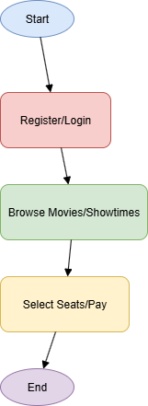

3.4 Sitemap

3.4.1 Site map User:

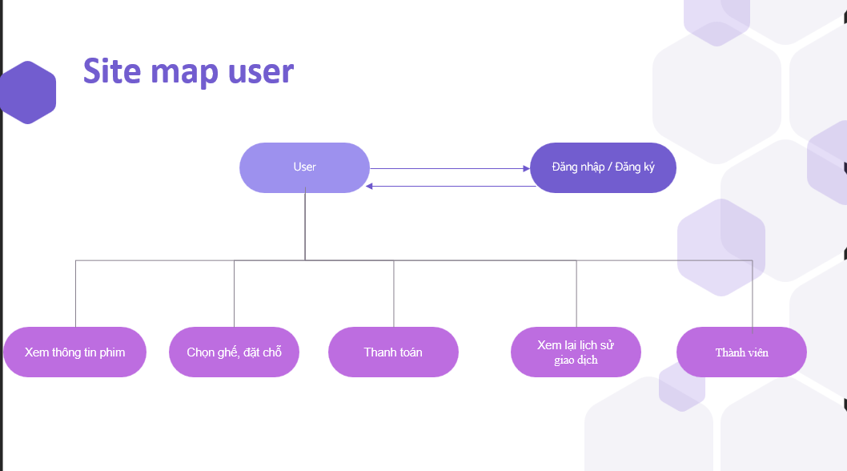
3.4.2 Site map Admin:

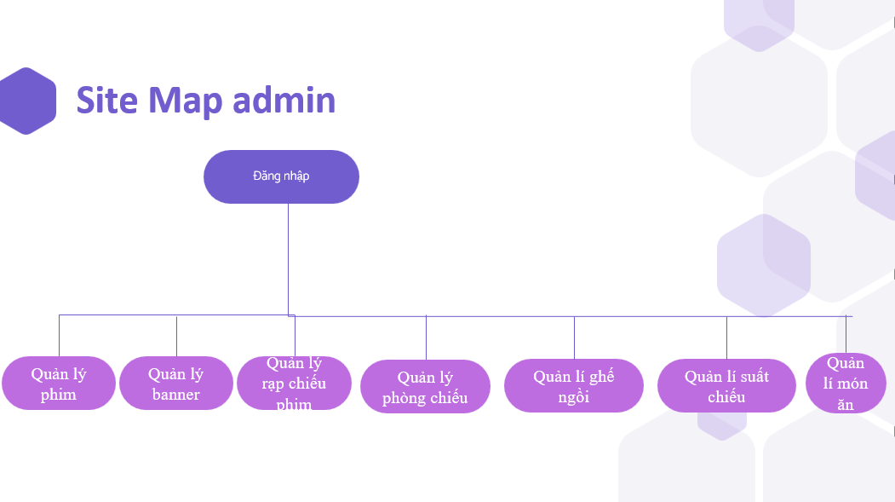

3.5 System Functions Design

3.5.1 User Interface

Mobile App (Flutter) UI Features
- Splash Screen
- Login/Register Screens
- Home Screen: Movie Banners, Lists
- Movie Details Screen
- Showtimes & Seat Selection Screen
- Food Combo Selection
- Payment Screen with PayPal Integration
- Booking History Screen
- Profile Management Screen (Avatar Upload)

User Interface is designed to be intuitive and user-friendly. Users who are not logged in can only browse movie lists (Now Showing, Coming Soon, Early Showing) and view movie details (poster, trailer, description, cast, showtimes). To access other features like seat selection, booking, payment, transaction history, or profile management, users must log in or register an account.

User Registration
- Purpose: Allow users to create an account.
- Flow:
  - Enter profile details (email, password, name, etc.).
  - Backend validates and hashes password (bcrypt).
  - Stores user in MySQL.
  - Sends verification email via email service.
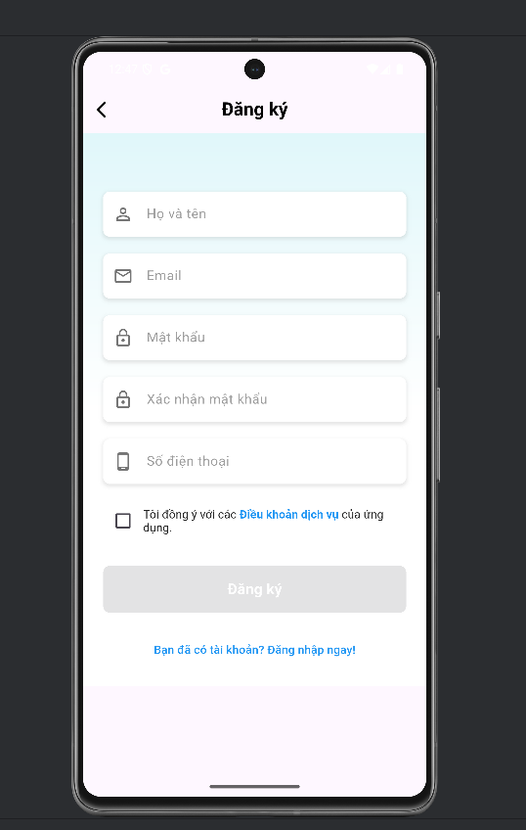

User Login / Google Sign-In
- Purpose: Authenticate users.
- Flow:
  - User provides credentials or Google ID token.
  - Backend verifies credentials.
  - Returns JWT token and user data.
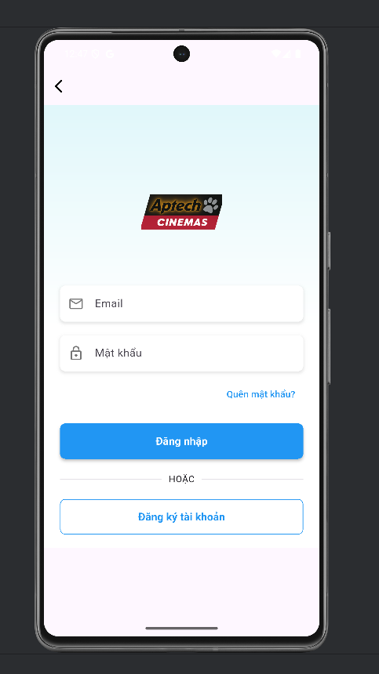
Browse Movies and Showtimes
- Purpose: Display categorized movie lists:
  - Now Showing (currently screening)
  - Coming Soon
  - Early Showing (special or advance showings)
- Features:
  - Users can tap any movie to view its details, watch trailer, see description, runtime, cast, and available showtimes.
- Flow:
  - App requests movie lists via API.
  - Backend filters by category/flags.
  - Returns JSON for Flutter to render sections and details pages.
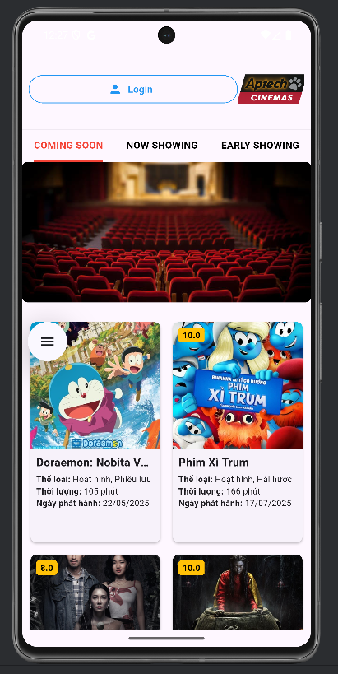

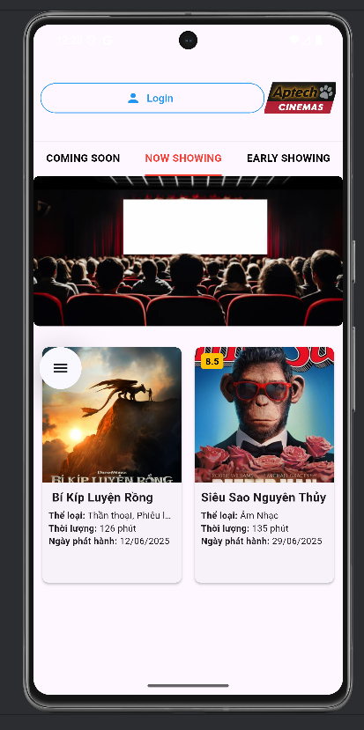

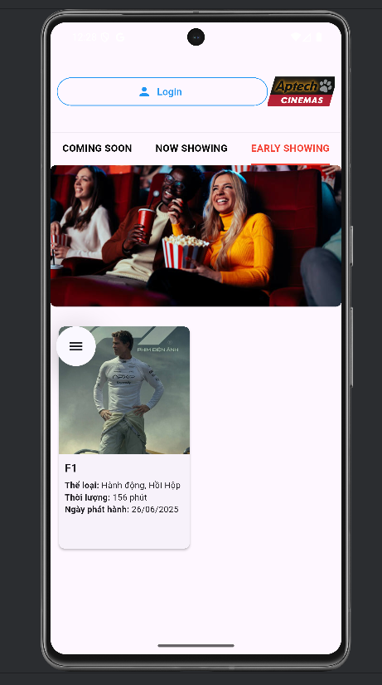

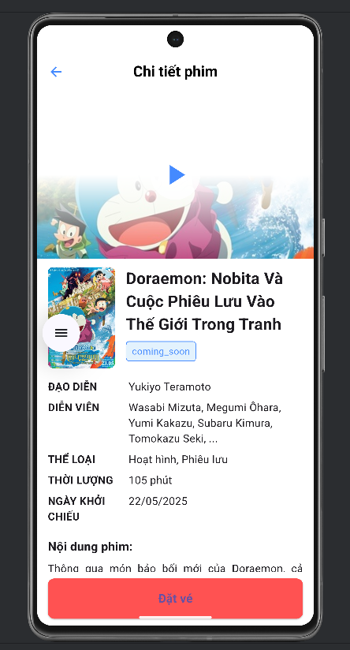

Seat and Showtime Selection
- Purpose: Let users select seats for a chosen showtime.
- Flow:
  - App shows interactive seat map.
  - User selects available seats.
  - Backend validates and reserves temporarily.
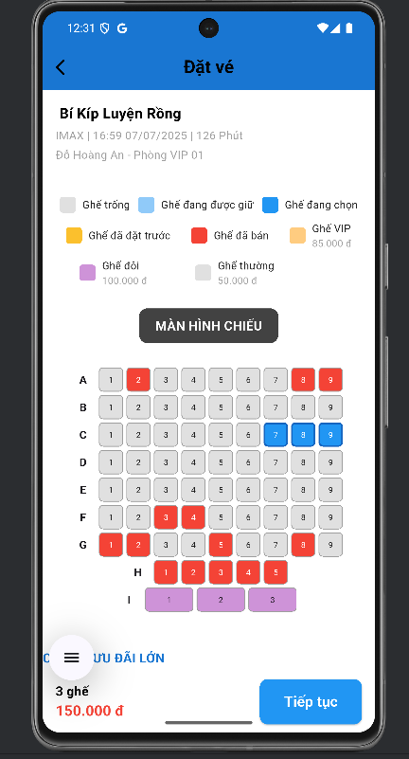

Select Food Combos
- Purpose: Offer upsell of food/drink combos.
- Flow:
  - App fetches food combo list from API.
  - User selects items and quantities.
  - Sent as part of booking request.

Booking and Payment (PayPal)
- Purpose: Confirm and pay for bookings securely.
- Flow:
  - User confirms booking.
  - App opens PayPal approval URL.
  - Backend executes payment, updates booking status, issues tickets.
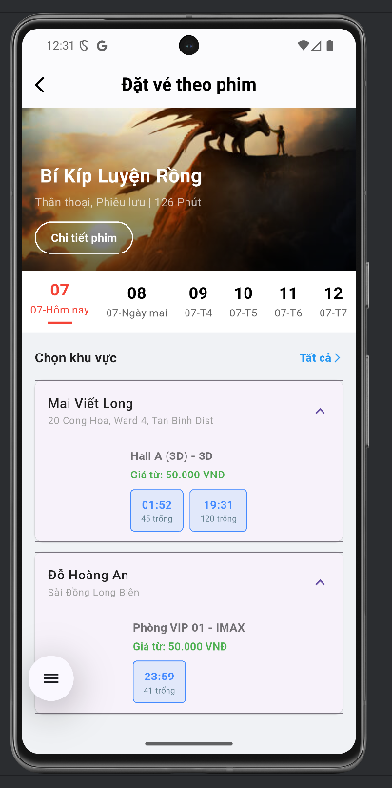

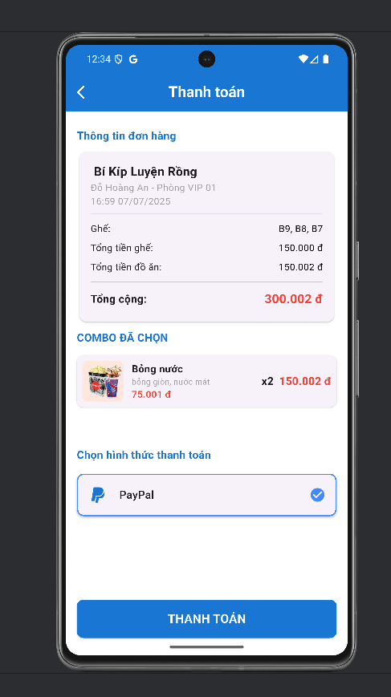
User Profile Management
- Purpose: Let users view and edit their profile.
- Flow:
  - User edits personal data.
  - Uploads avatar to Cloudinary.
  - Backend updates MySQL users table.
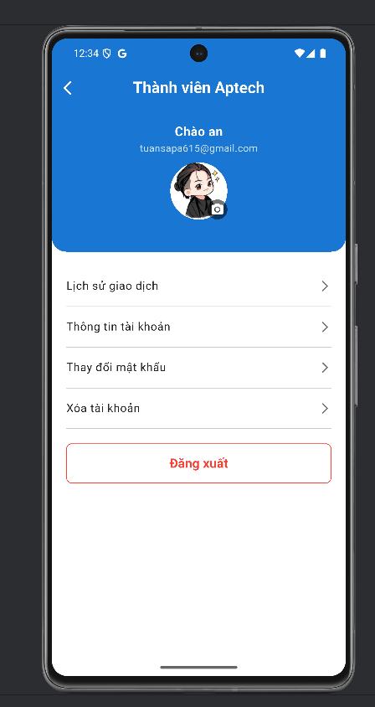

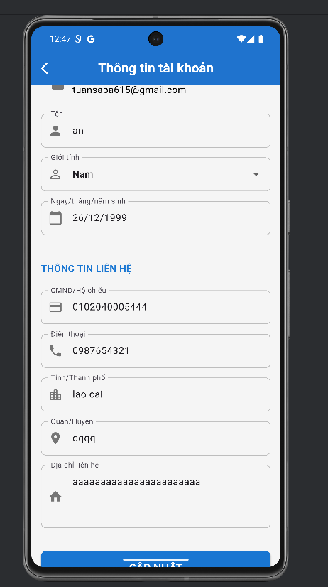

View Transaction History
- Purpose: Show user's past confirmed bookings.
- Flow:
  - App fetches bookings with status 'confirmed'.
  - Displays details: seats, combos, barcode.
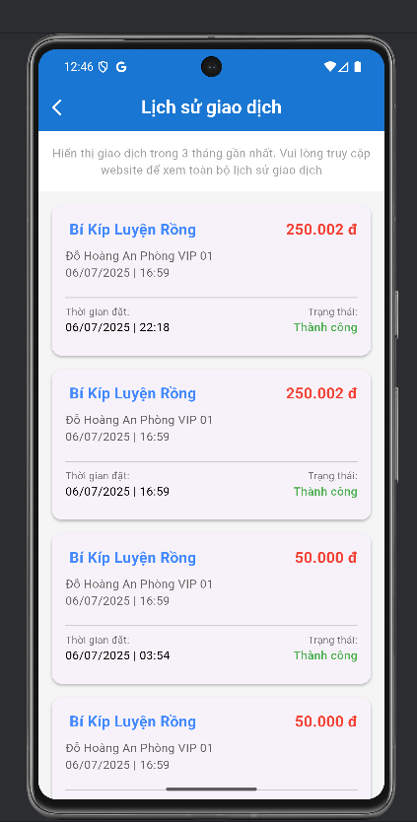

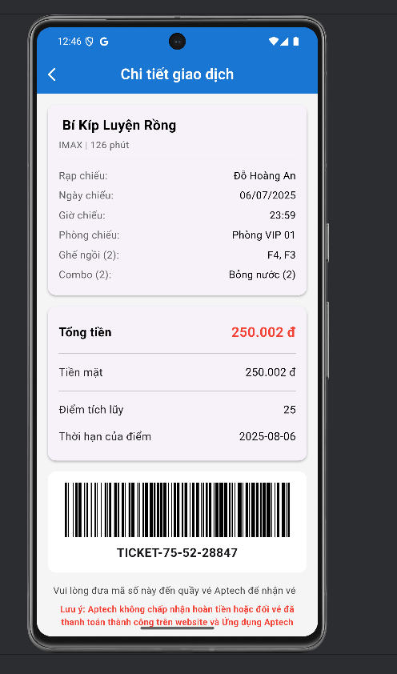

3.5.2 Admin Interface

Admin Interface (Admin Panel) is designed as a simple, intuitive dashboard. After logging in, the admin can access the following main features:
- Dashboard Overview
  - Displays quick stats: number of movies, showtimes, cinemas/halls, tickets sold.
  - Summarizes upcoming showtimes and recent bookings.
- Movie Management
  - Add, edit, delete movies.
  - Update posters, trailers, and descriptions.
- Banner Management
  - Add, edit, delete banners shown in the user app.
  - Manage banner activation status.
- Showtime Management
  - Create, edit, delete showtimes.
  - Assign movies, cinemas, halls, and specific times.
- Cinema Management
  - Add, edit, delete cinema information.
  - Manage names, addresses, and contact details.
- Hall Management
  - Add, edit, delete halls within cinemas.
  - Configure seat maps and hall details.
- Seat Management
  - Update seat maps and types.
  - Set pricing per seat type.
- Food Combo Management
  - Add, edit, delete food combos.
  - Update pricing and images of food items.

- Tech: React Admin panel, Node.js/Express REST API.
- Security: JWT tokens with role-based access.

Admin Login Page
- Allows the admin to enter email and password to log in.
- Enforces access control so only users with the "admin" role can access the dashboard.

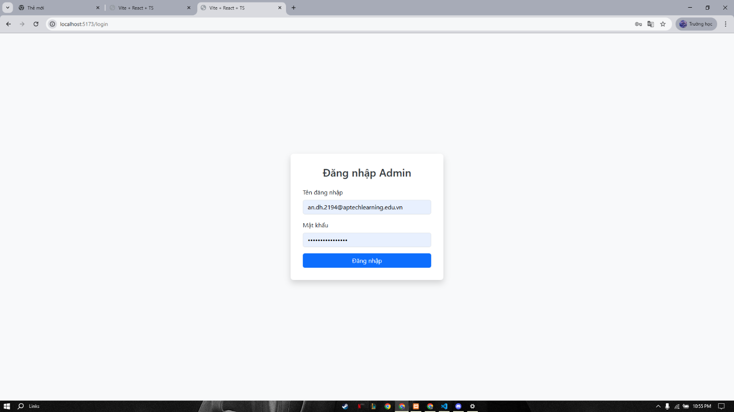

Dashboard Overview
- Displays key statistics to help admins monitor the system.
- The displayed information includes:
  - Number of Movies: total count of movies managed in the system.
  - Total Users: total number of registered user accounts.
  - Total Showtimes: total number of movie showtimes created.
  - Total Revenue: total amount collected from completed ticket payment transactions.
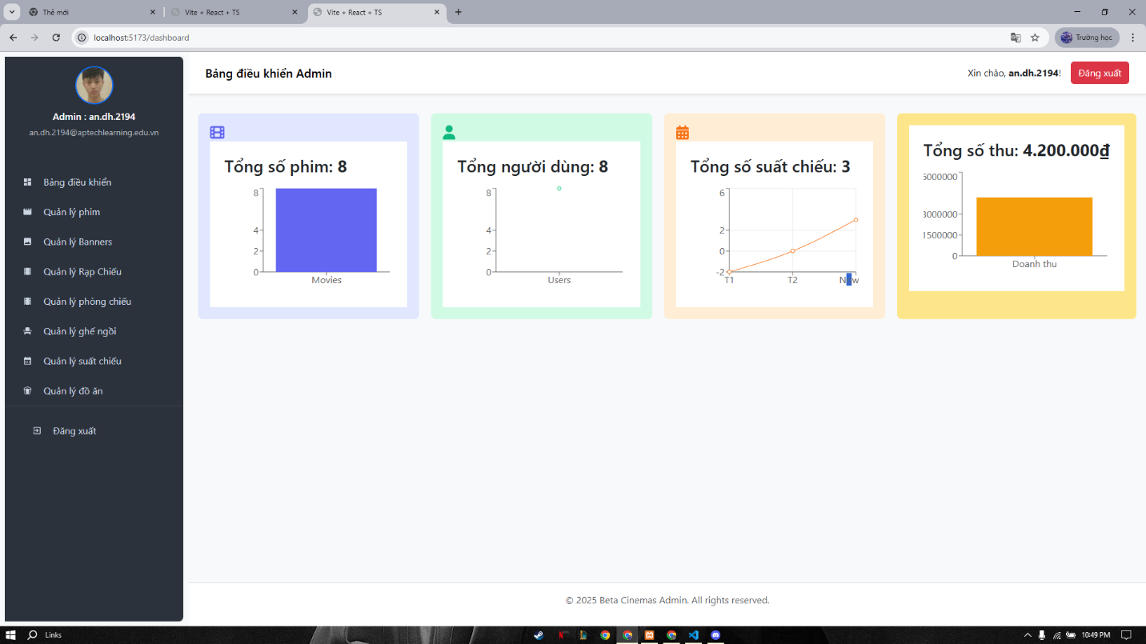

Movie Management
- List of movies with poster and trailer.
- Add new movies: title, description, cast, genre, duration.
- Edit movie details, replace poster/trailer.
- Delete movies no longer showing.

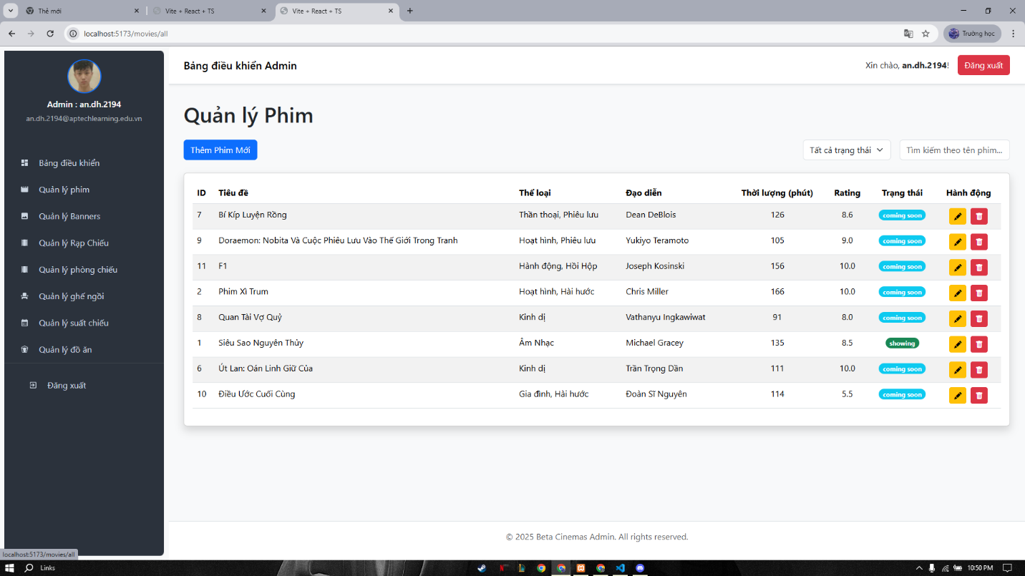

Banner Management
- Upload and edit promotional banners shown in the app.
- Enable/disable banners.

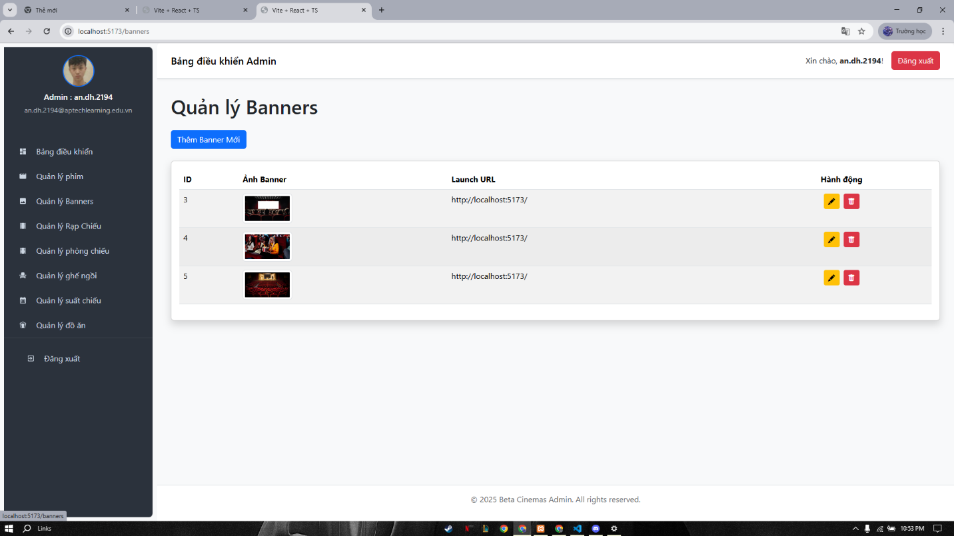

Cinema & Hall Management
- Add new cinemas.
- Add/edit/delete halls within cinemas.
- Manage seat maps and seat types.

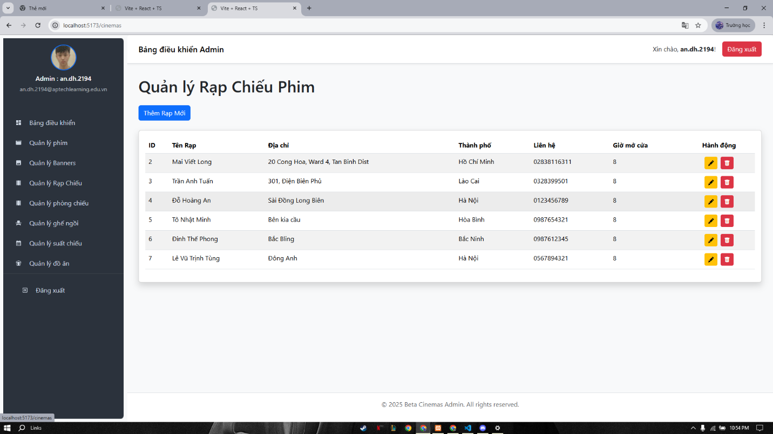

Seat Management
- Update seat maps, define seat types and pricing.
- Adjust seat type prices per showtime.

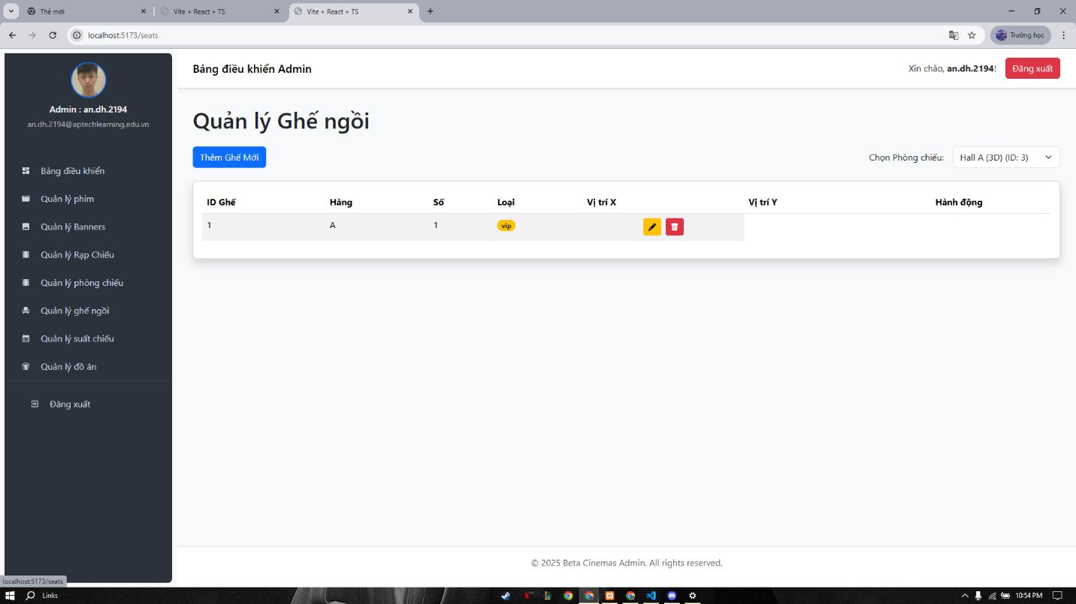

Showtime Management
- Create new showtimes by selecting movie, cinema, hall, time.
- Edit or cancel showtimes.
- Check seat availability for each showtime.

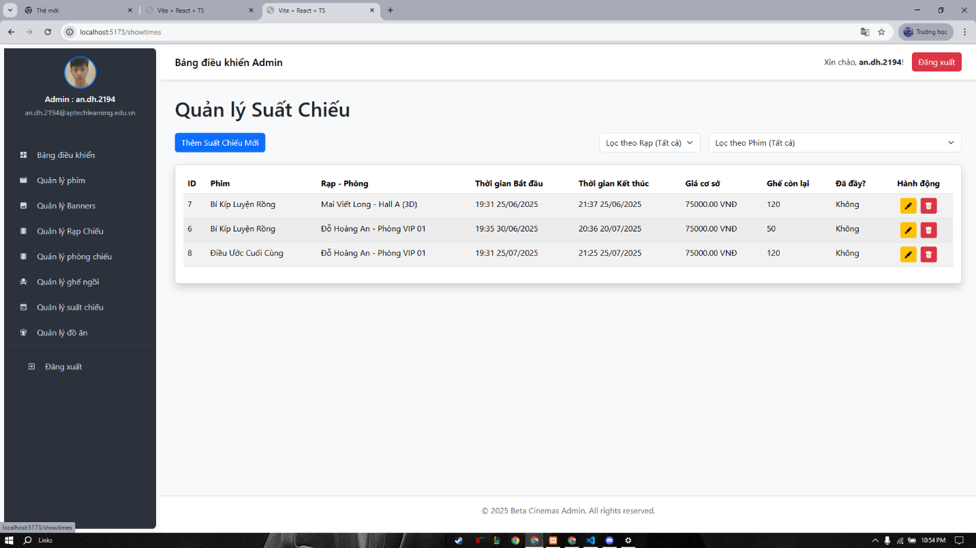

Food Combo Management
- Add/edit/delete food combos sold with tickets.
- Update images and pricing.

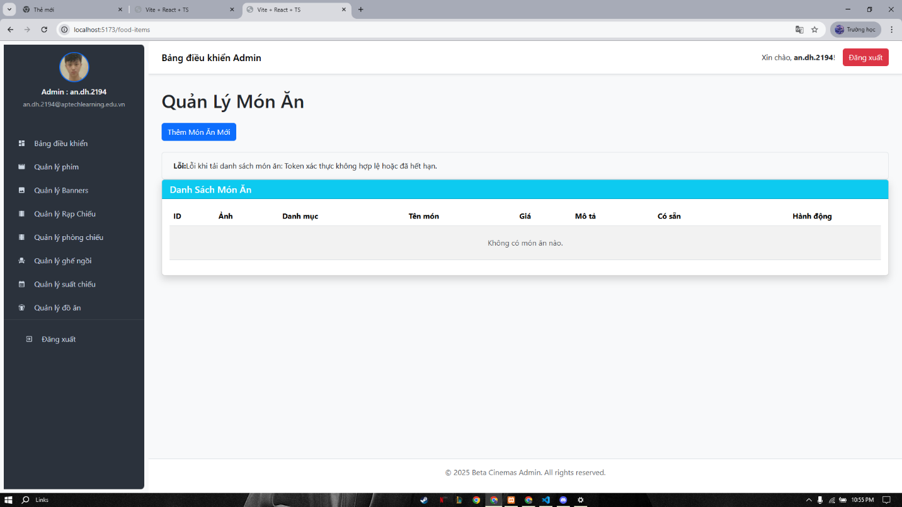

Task sheet

Task | Start Time | Finish Time | Implemented by | Evaluation (%)
Feasibility study phase

Viết tài liệu | 29/05/2025 | 31/05/2025 | Đỗ Hoàng An | 30%
Đóng góp ý kiến | 29/05/2025 | 31/05/2025 | Lê Vũ Trịnh Tùng | 15%
Đóng góp ý kiến | 29/05/2025 | 31/05/2025 | Đinh Thế Phong | 10%
Đóng góp ý kiến | 29/05/2025 | 31/05/2025 | Tô Nhật Minh | 15%
Duyệt và sửa nội dung | 29/05/2025 | 31/05/2025 | Trần Anh Tuấn, Mai Viết Long | 30%
Requirement Analysis phase
Viết tài liệu | 31/05/2025 | 06/06/2025 | Mai Viết Long | 35%
Đóng góp ý kiến | 31/05/2025 | 06/06/2025 | Lê Vũ Trịnh Tùng | 10%
Đóng góp ý kiến | 31/05/2025 | 06/06/2025 | Đinh Thế Phong | 10%
Đóng góp ý kiến | 31/05/2025 | 06/06/2025 | Tô Nhật Minh | 10%
Duyệt và sửa nội dung | 31/05/2025 | 06/06/2025 | Trần Anh Tuấn, Đỗ Hoàng An | 35%
Design phase
Đóng góp ý kiến | 07/06/2025 | 13/06/2025 | Tô Nhật Minh | 10%
Thiết kế giao diện | 07/06/2025 | 13/06/2025 | Mai Viết Long, Đinh Thế Phong | 30%
Thiết kế DB | 07/06/2025 | 13/06/2025 | Trần Anh Tuấn | 50%
Duyệt và sửa nội dung | 07/06/2025 | 13/06/2025 | Đỗ Hoàng An, Lê Vũ Trịnh Tùng | 10%
Development phase
Viết code | 14/06/2025 | 02/07/2025 | Đỗ Hoàng An  Lê Vũ Trịnh Tùng  Đinh Thế Phong  Tô Nhật Minh  Trần Anh Tuấn  Mai Viết Long | 70%
Đóng góp ý kiến | 14/06/2025 | 02/07/2025 | Đỗ Hoàng An, Tô Nhật Minh | 15%
Đóng góp ý kiến | 14/06/2025 | 02/07/2025 | Trần Anh Tuấn | 15%
Testing phase
Chạy thử | 02/07/2025 | 03/07/2025 | Trần Anh Tuấn  Đỗ Hoàng An | 50%
Chạy thử | 02/07/2025 | 03/07/2025 | Mai Viết Long  Đinh Thế Phong | 25%
Chạy thử | 02/07/2025 | 03/07/2025 | Lê Vũ Trịnh Tùng  Tô Nhật Minh | 25%
Deployment phase
Triển khai và hoàn thiện | 04/07/2025 | 06/07/2025 | Mai Viết Long  Đinh Thế Phong | 30%
Triển khai và hoàn thiện | 04/07/2025 | 06/07/2025 | Tô Nhật Minh  Đỗ Hoàng An | 35%
Triển khai và hoàn thiện | 04/07/2025 | 06/07/2025 | Lê Vũ Trịnh Tùng  Trần Anh Tuấn | 35%

